Back

Probability distributions

Quiz, 15 questions

1  
point

**1. Question 1**

The ice cream shop has problems with the delivery of the different flavours. As a consequence the shop doesn't have the same amount of flavours every day. In the following list you see the probability distribution of the different amounts of flavours.

Amount of flavours (*probability*)

4 (*0.14*)

5 (*0.35*)

6 (*0.31*)

7 (*0.20*)

What is the mean amount of flavours the ice cream shop sells? Give your answer in two decimals.



Question 2

1  
point

**2. Question 2**

Which of the following statements is/are correct?

I. A discrete random variable can take a finite number of distinct values.

II. Height (as measured in cm) is an example of a continuous random variable.



Statement I is true, statement II is false.



Statement II is true, statement I is false.



Both statements are false.



Both statements are true.

Question 3

1  
point

**3. Question 3**

A researcher is interested in the time people spend online on social-media per day. She plots the probability distribution for this variable using hours as the unit, and it looks as follows:

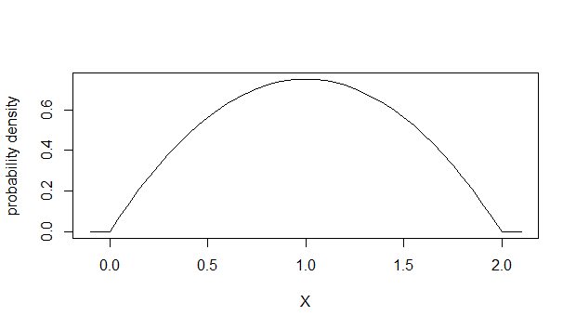

What happens to the graph if she decides to measure the time in minutes instead of hours?



The graph becomes steeper.



The graph becomes flatter.



The graph stays the same. Only the values on the x-axis change.



The graph stays the same apart from the values on both axes.

Question 4

1  
point

**4. Question 4**

Consider the following discrete probability distribution.

|  |  |
| --- | --- |
| ***X*** | ***P(x)*** |
| 1 | 0.20 |
| 2 | 0.33 |
| 3 | 0.06 |
| 4 | 0.27 |
| 5 | 0.14 |

What is the probability of *X*being higher than 2?



0.80



0.33



0.53



0.47

Question 5

1  
point

**5. Question 5**

You investigate the number of earthquakes that occur in a year. You get the following outcomes:

https://d3c33hcgiwev3.cloudfront.net/imageAssetProxy.v1/GDSUXKznEeWzcxKZFP5xpQ_6aed1bdf79d077cf8b77cb6d8aa8bdea_Earth.png?expiry=1532822400000&hmac=Yo1sT8fOEh6hpM9cg2VzuSoKIonxU7vjxvFxsJWnXNg

What is the variance of this random phenomenon?



0.52



4.59



0.11



0.94

Question 6

1  
point

**6. Question 6**

You have a random variable *X*with variance 3. Now you multiply *X* with 2. What becomes the variance of *X*?



12



3



7



6

Question 7

1  
point

**7. Question 7**

Imagine you're investigating the time people wait at traffic lights, a variable which appears to be approximately normally distributed with a mean of 1.3 minutes and a standard deviation of 0.57 minutes. Which of the following intervals contains 95% of the waiting times?



0.16 and 2.44



0.73 and 1.87



1.3 and 2.44



0.16 and 1.3

1  
point

**8. Question 8**

You investigate the earnings of the 2nd year students in your school. They earn on average €240,-, with a standard deviation of €90,- One person stands out, because she's a snooker champion. She makes on average €420,- a week. What is the corresponding z-score of her earnings? Give your answer in one decimal.



1  
point

**9. Question 9**

On average, a proportion of 0.48 newborns are girls. What are the chances that in a family with 4 children there are exactly three daughters.

Give your answer as a proportion, rounding to two decimal places.



Question 10

1  
point

**10. Question 10**

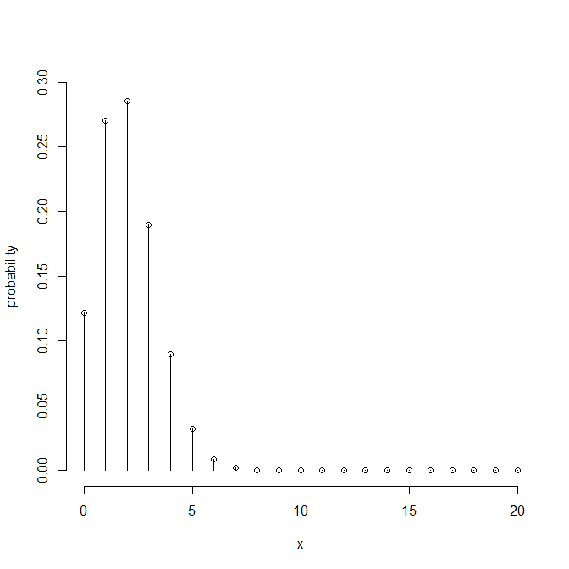

Looking at the binomial distribution above, what would be reasonable values for the parameters of this distribution?



number of trials = 2, probability of success = 0.29



number of trials = 20, probability of success = 0.29



number of trials = 2, probability of success = 0.1



number of trials = 20, probability of success = 0.1

1  
point

**11. Question 11**

A multiple choice exam consists of 12 questions, each having 5 possible answers. To pass you must answer at least 8 out of 12 correctly. What are your chances of passing if you go into the exam without knowing a thing and resort to pure guessing?

Give your answer as a proportion, rounding to three decimal places.



1  
point

**12. Question 12**

The total time that I wait for busses on a long trip has the following probability density function.

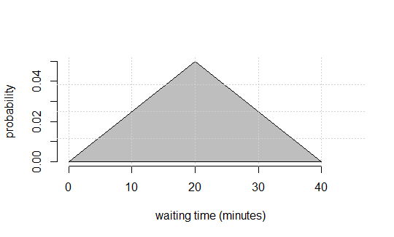

What is the chance that I will have to wait for more than 30 minutes?

Give your answer as a proportion, rounding to three decimal places.



1  
point

**13. Question 13**

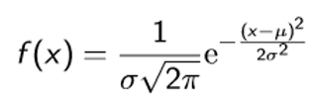

The equation above describes a normal distribution for a random variable *X*.

It appears that the time people in the age range of 20 to 50 years spend sleeping is approximately normally distributed with a mean of 7 hours and a standard deviation of 1 hour. Can you estimate the height of this probability density curve at the mean and also give the unit of this value?

Give your answer as a proportion, rounding to two decimal places.



1  
point

**14. Question 14**

For a normally distributed variable with a mean of 10 and standard deviation of 5, what is the proportion of the data with negative values?

Give your answer as a proportion, rounding to three decimal places.



Question 15

1  
point

**15. Question 15**

The following figure shows two lines that are meant to represent the cumulative probability distribution of the age of trees in a young forest where the oldest tree is 10 years.

What can you say about these two cumulative distribution functions (cdfs)?

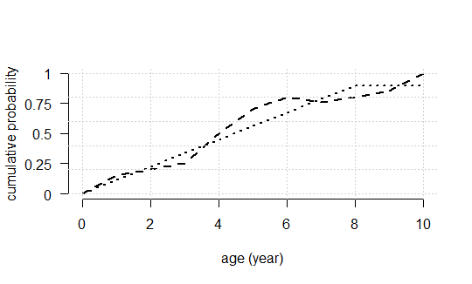



Neither of these is a proper cdf.



The dotted line represents a proper cdf, the dashed line doesn't.



The dashed line represents a proper cdf, the dotted doesn't.



Both lines can be proper cdfs.

Upgrade to submit